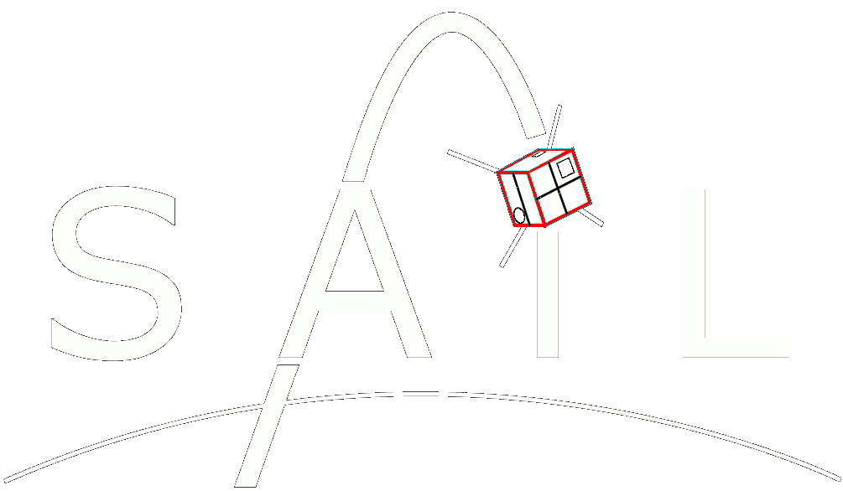

COMPASS

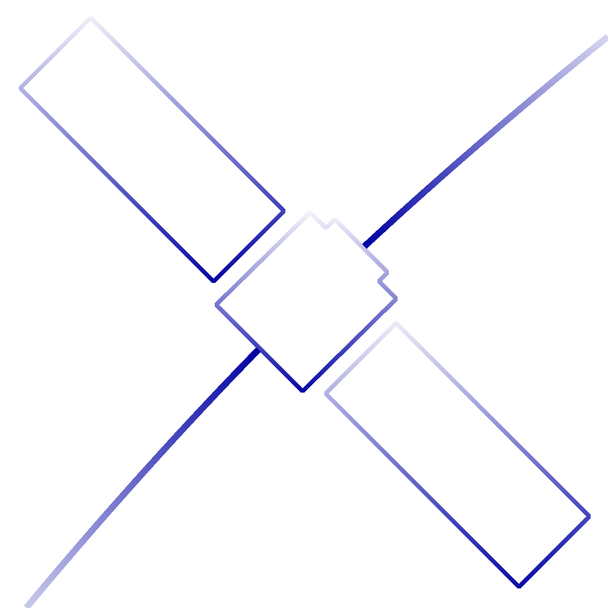Software Design Document

Embry-Riddle Aeronautical University

Daytona Beach, FL

Requirements

|  |  |
| --- | --- |
| No. | Description |
| 1.0 | The program shall produce accurate renderings of RSO’s. |
| 1.1 | Camera position shall be determined according to the relative locations of the RSO and the telescope. |
| 1.2 | An “up-close” rendering mode shall be implemented to produce accurate brightness data. |
| 1.3 | A “telescope-view” rendering mode shall be available to simulate actual pass observations. |
| 2.0 | The program shall generate accurate photometry curves from simulated RSO passes. |
| 3.0 | The program shall reconstruct the attitude of an RSO given its shape and photometry data. |
| 4.0 | The program shall provide a graphical user interface. |
| 4.1 | The GUI shall be created with QT. |
| 4.2 | The GUI shall provide a render mode to view the RSO renderings. |
| 4.3 | The GUI shall provide a graph mode to view photometry data independently. |

Architecture

CpsWindow

* Represents the main program window
* Has a GLWidget and a CpsGraph

CpsGraph

* Live-Graph Widget
* Graphs brightness in real-time

GLWidget

* Handles OpenGL initialization
* Handles Rendering
* Handles GL viewport resize